Table of Contents

Class13.More on Designer Workflow 1

1.Ceating Notification email 1

2.Creating WorkFlow 4

SharePoint 2013 Workflow 4

Else Condition: 15

Set workflow status 16

Editing to send Notification email 16

SharePoint 2010 Workflow 19

Compare 2013 and 2010 SharePoint Designer 19

How to Add custom Task 23

# Class13.More on Designer Workflow

# MTMTask

# 

# C:\Users\Nega\Desktop\Images\m1.png

# 1.Ceating Notification email

# C:\Users\Nega\Desktop\Images\m2.png

**Open it on Classic experience**

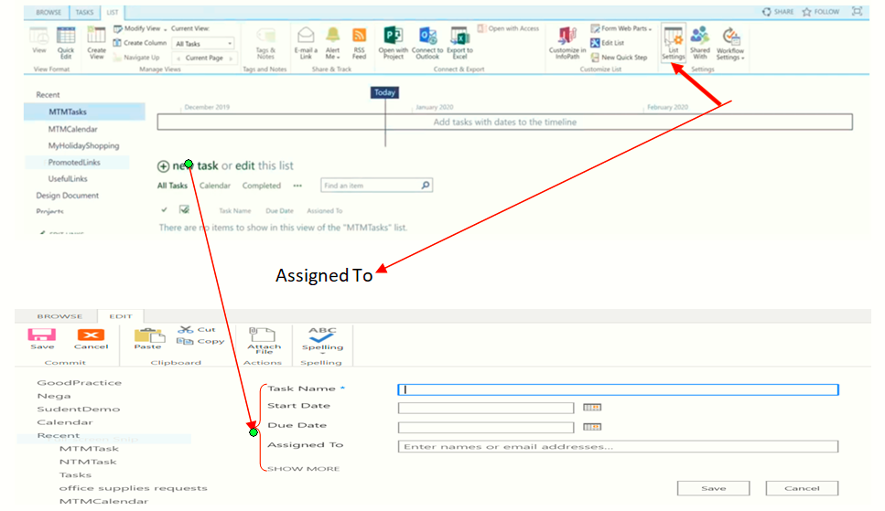

If it is **High Priority** send email but it sends after some modification.eg”some desc is needed”

If we want display “ Priority “ on the front: **modify =>select it then save**

**Go to SPD**

**Open MTMTask =>List =>Edit List On SPD blog() => Open Microsoft office 2013 =>yes**

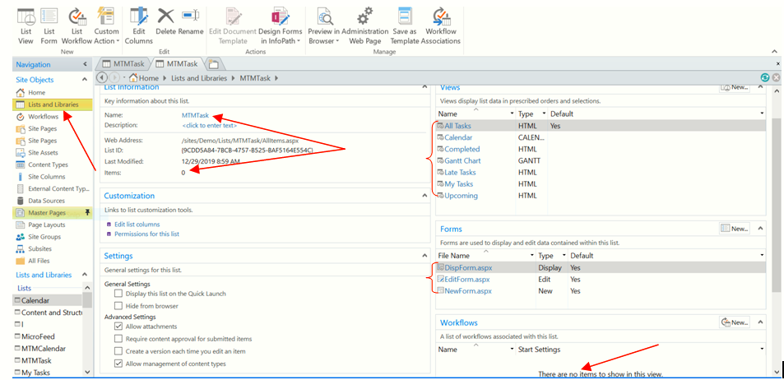

**Custom Action:**

Used to add button to ribbon area.

**Workflow**

To check workflow

**Case1: Using SPD**

Open SPD => open any lists or libraries as you want => then check as we see above

**Case2: Using SP**

Open any lists or libraries as you want =>List => Workflow Setting

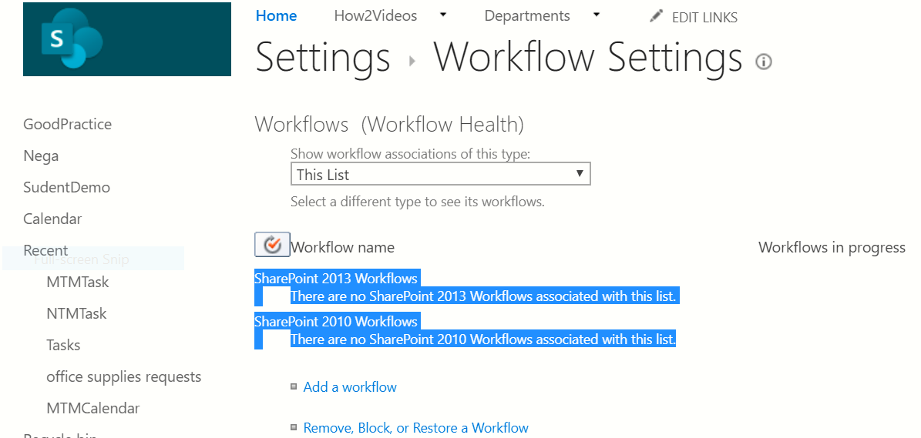

# 2.Creating WorkFlow

## SharePoint 2013 Workflow

Open your list and Libraries => write Name(High priority notification)

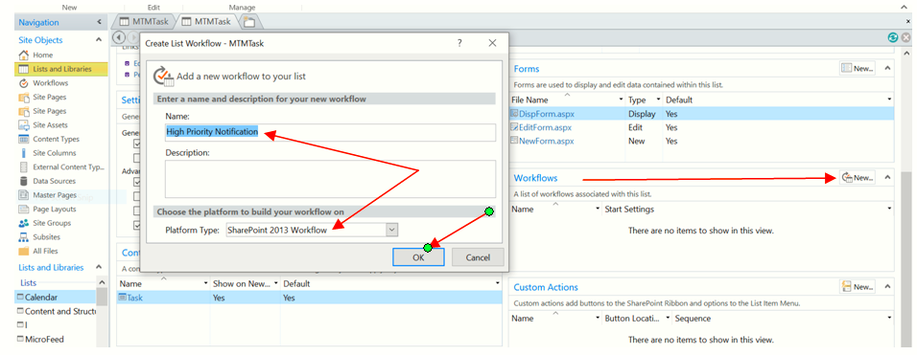

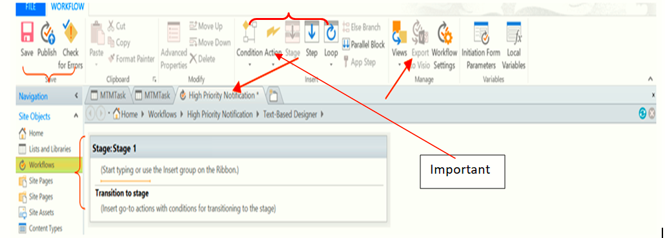

**Outside Activation**: Click outside **Stage** to be active Stage

**Inside Activation**: Click inside **Stage** to be active **Condition, Action, Step and Loop.**

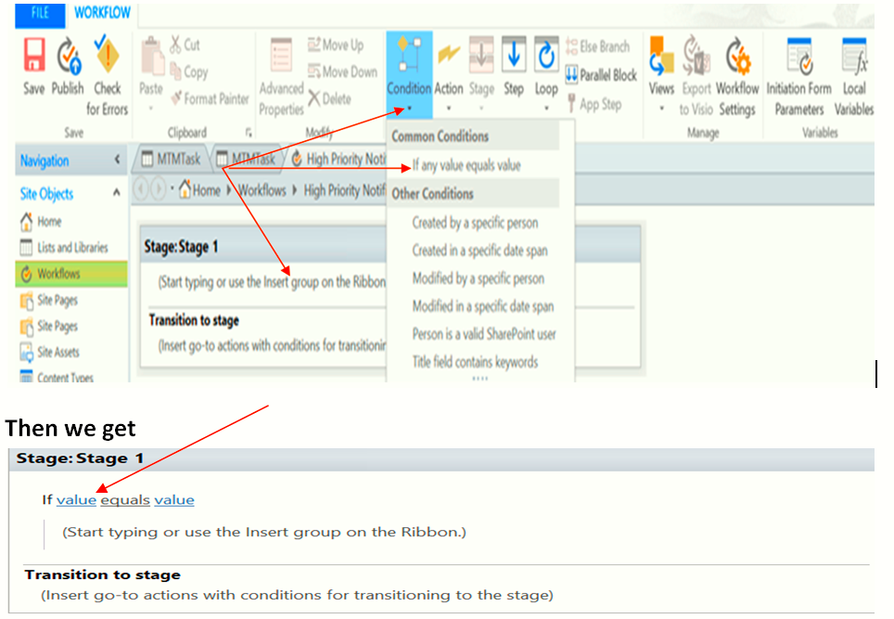

**NB**: As we have seen the above there is the **Condition in the 1st Line** and an **Action in the 2nd Line**.

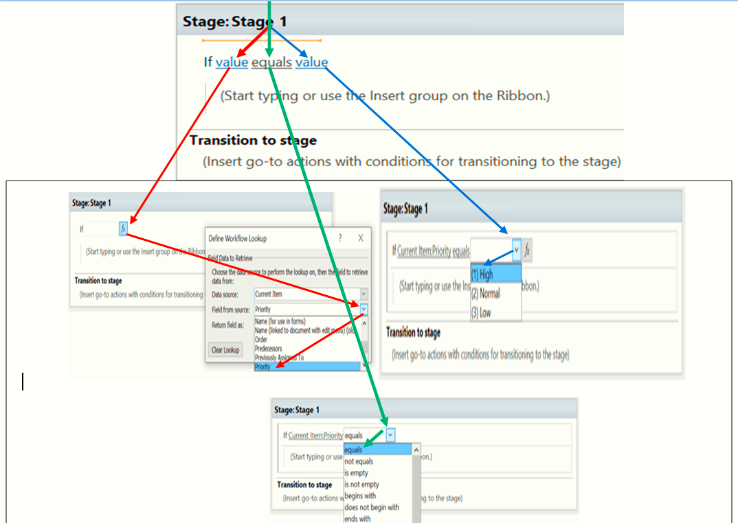

**NB:** How to open to **edit** our workflow

Open SPD => Go to List => Open Our List/Library =>Go to Workflow => Open

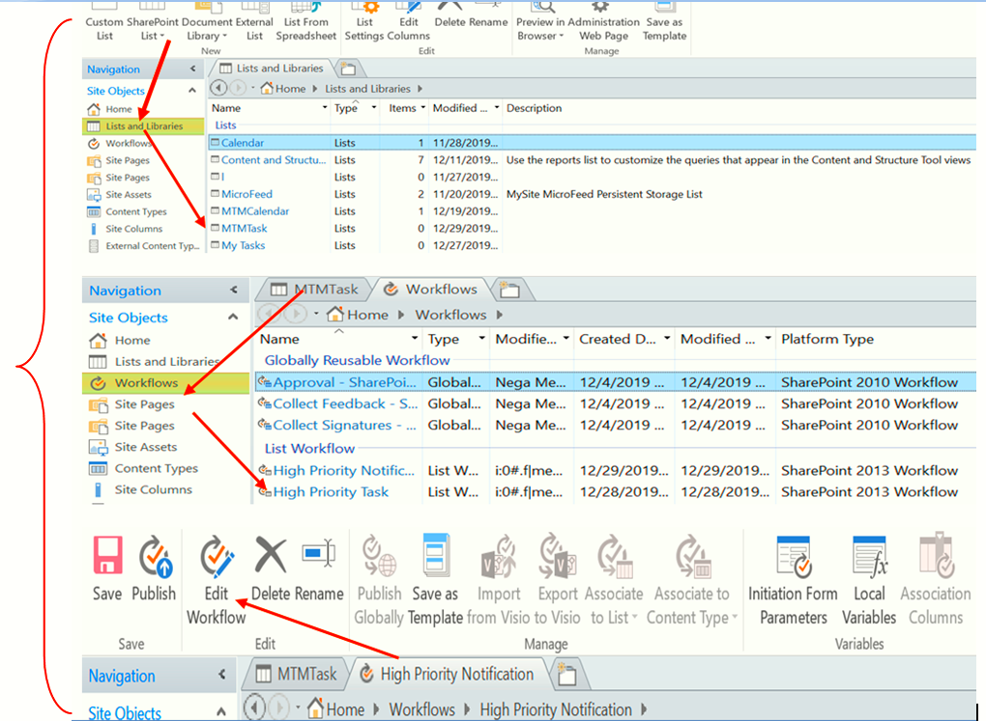

We have to follow two ways to do an action on the 2nd line => **either writing on the line or searching under Action**

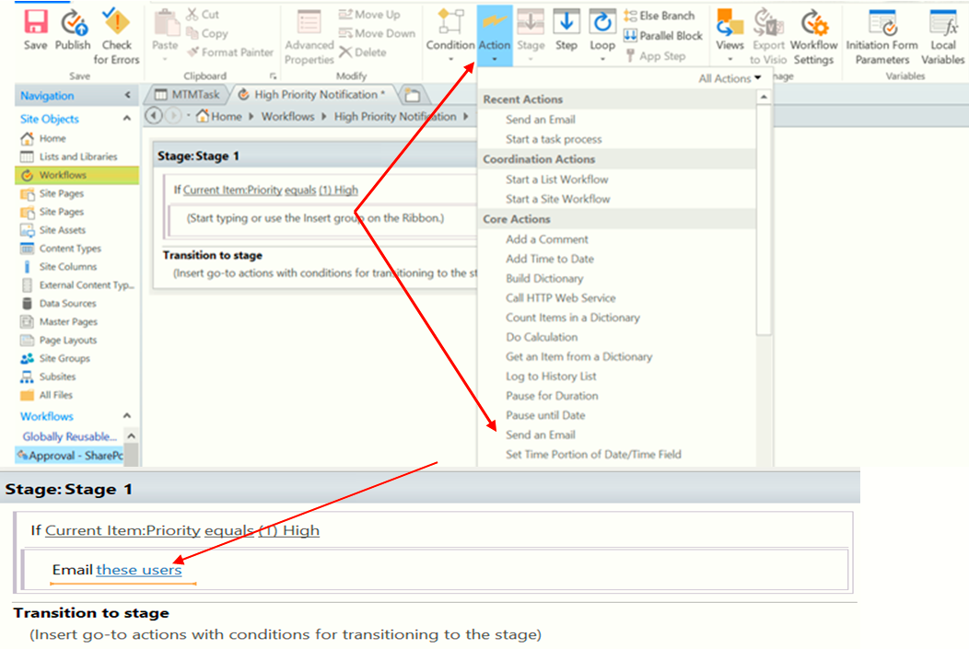

**Hi [Assigned To Name]**

**[Who ever created] created a high priority for you.**

**Task Due is:**

**Please review and act on it**

**Thanks**

1. **For Hi and Created: …………………………………**

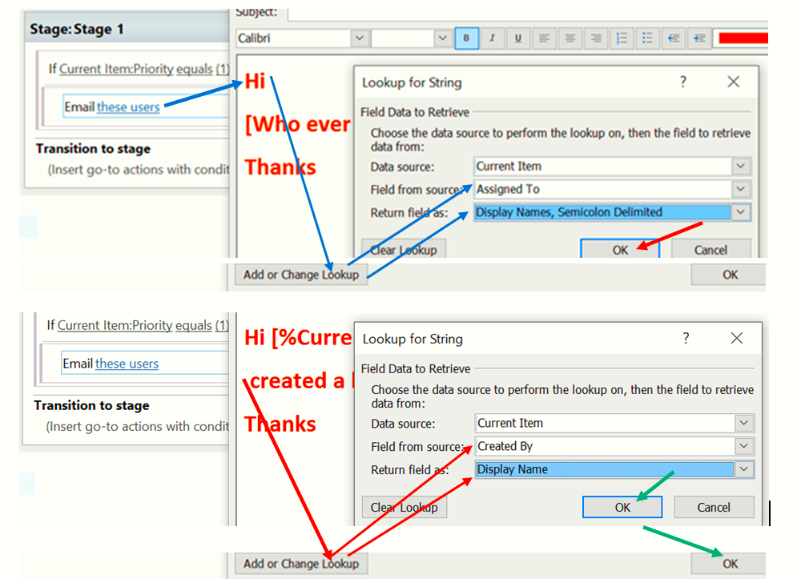

**Then we get**

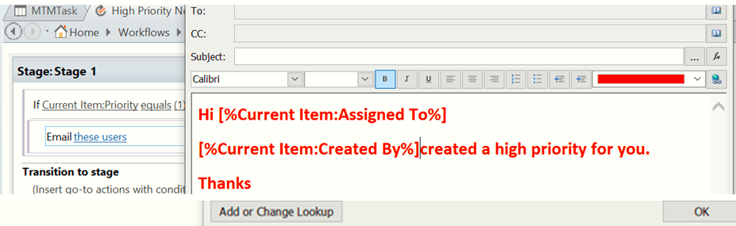

1. **For Due date: …………………………………………….**

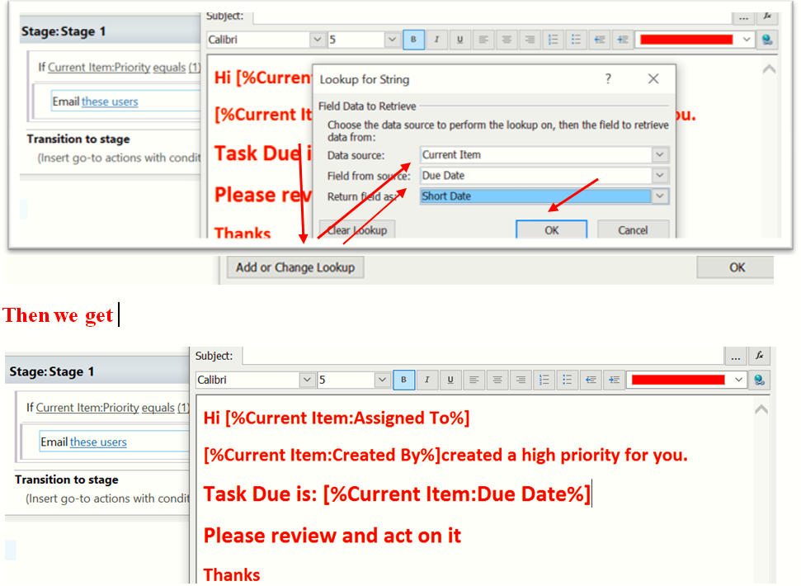

1. **For To………………..**

**And Subject: ……………….**

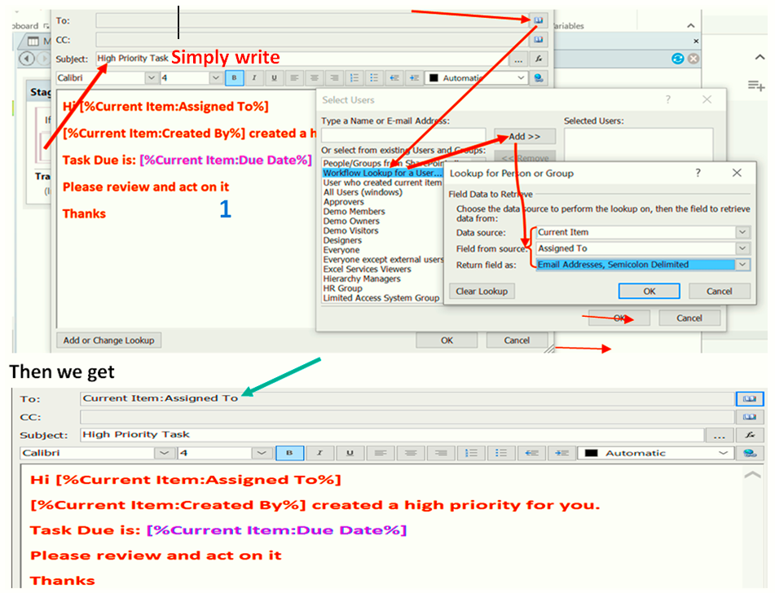

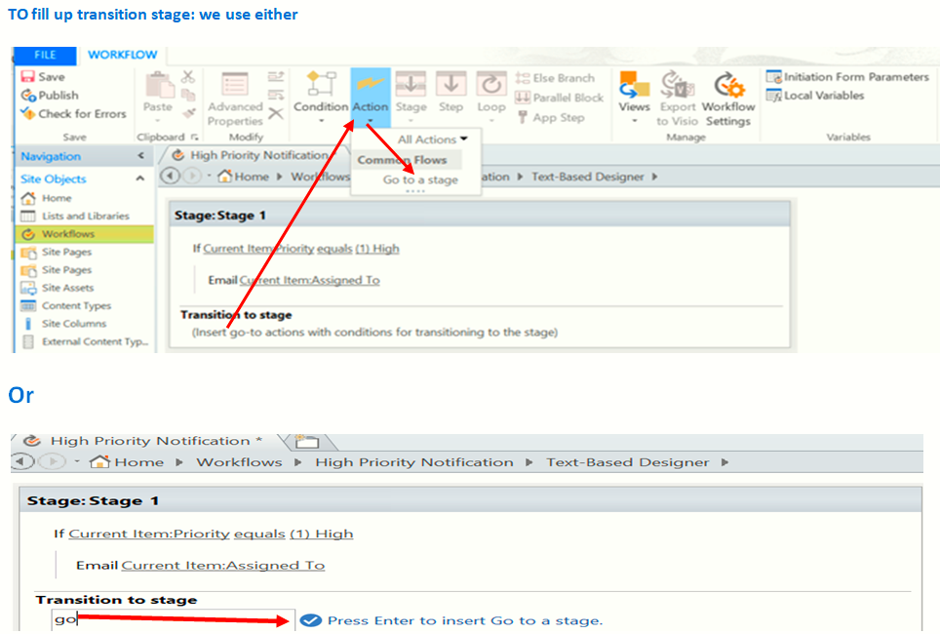

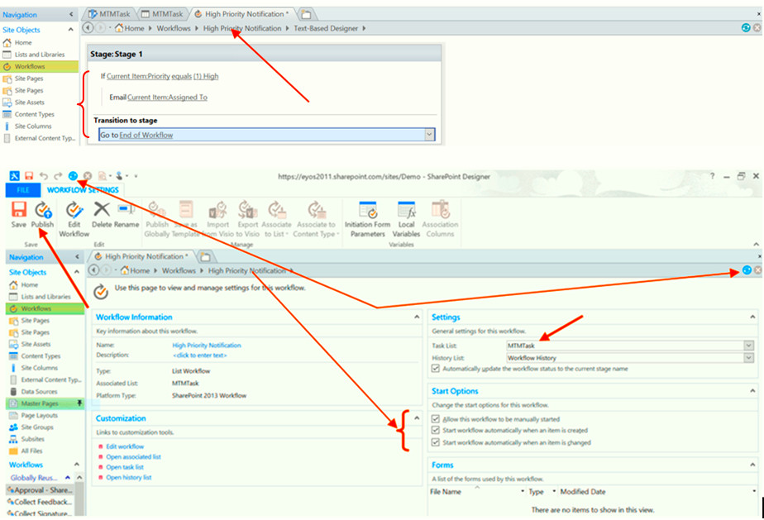

**Then we get**

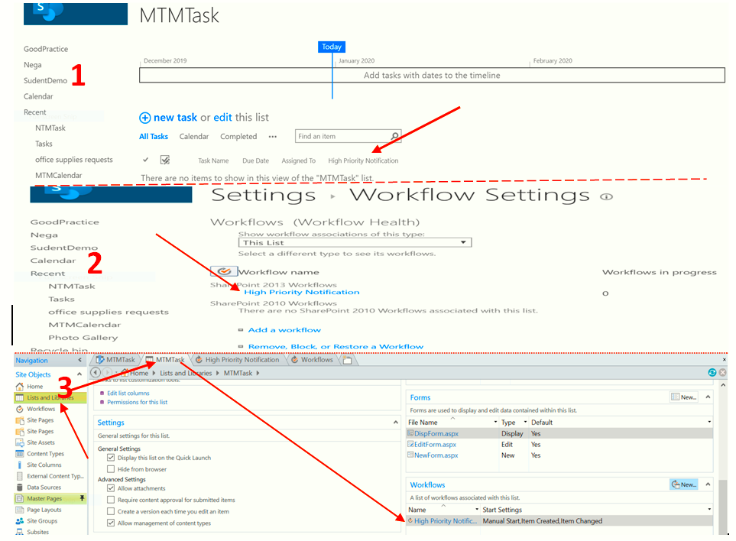

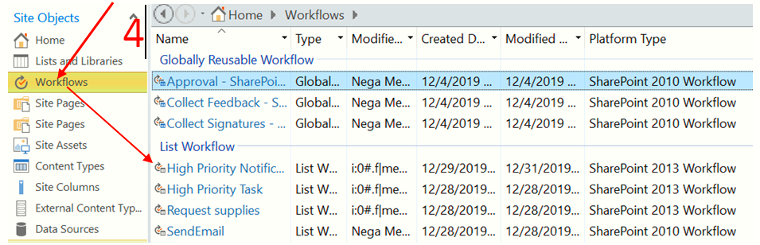

**Checking Option**

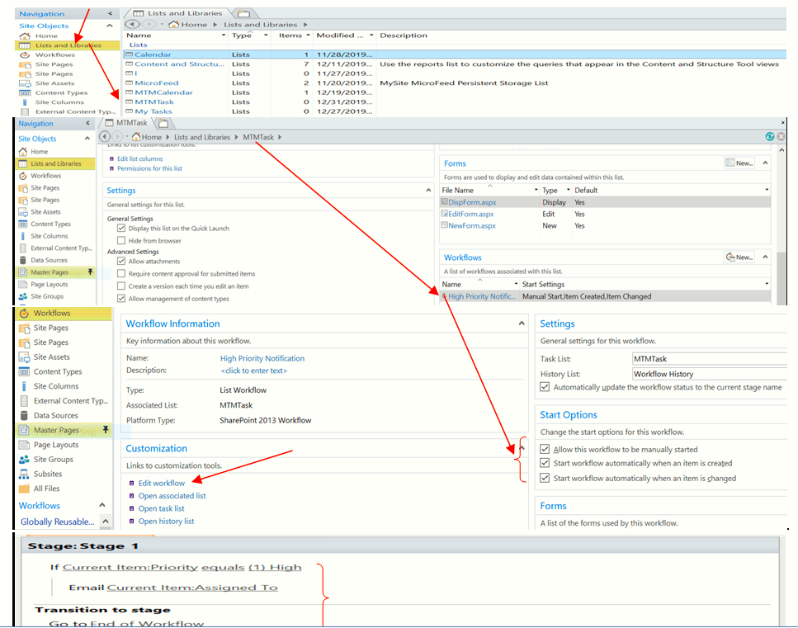

**Go to browser and open MTMTask and then check the Notification email**

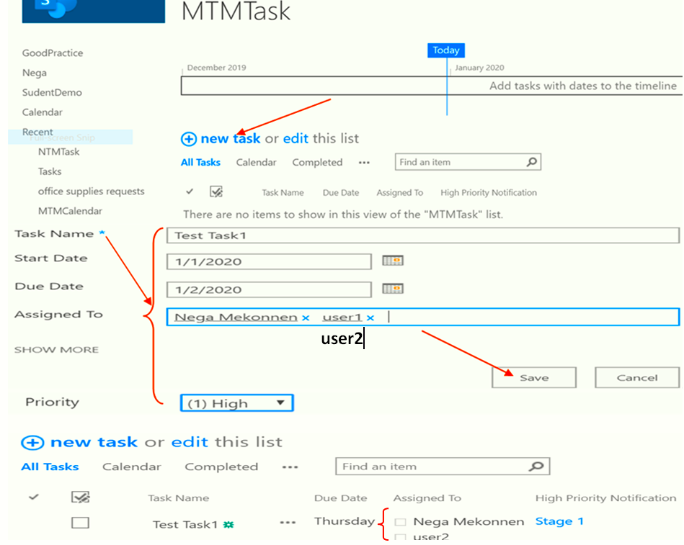

**If we click on stage1 we get**

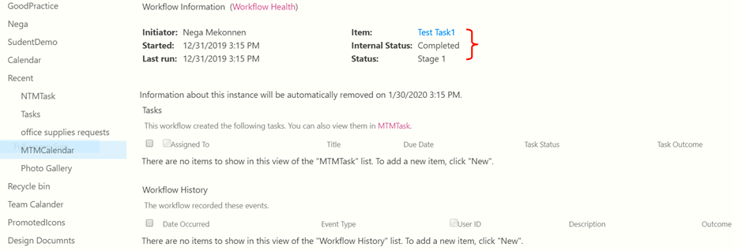

Then we get the following **Email Notification**

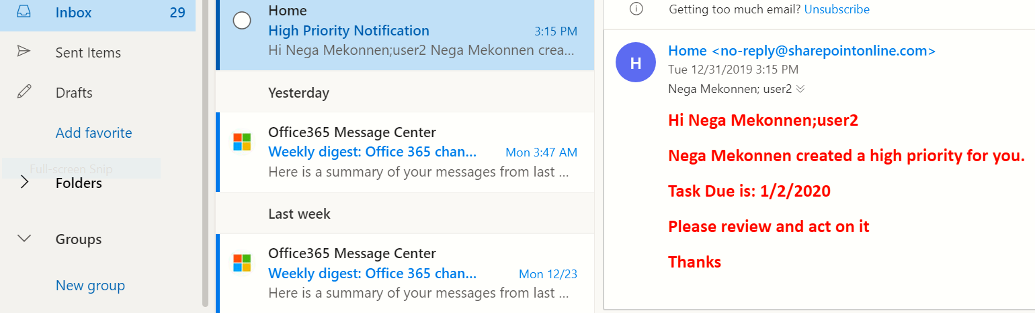

**If it is not High Priority, Notification Email not send**

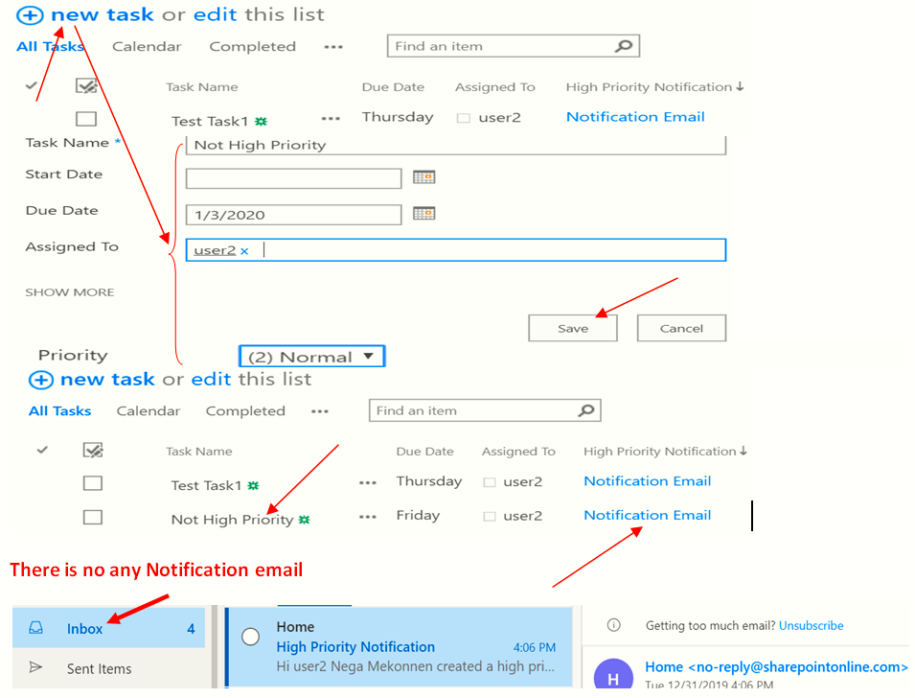

If we do this step as it is by changing priority value: from Normal to Higher, we get Notification Email.

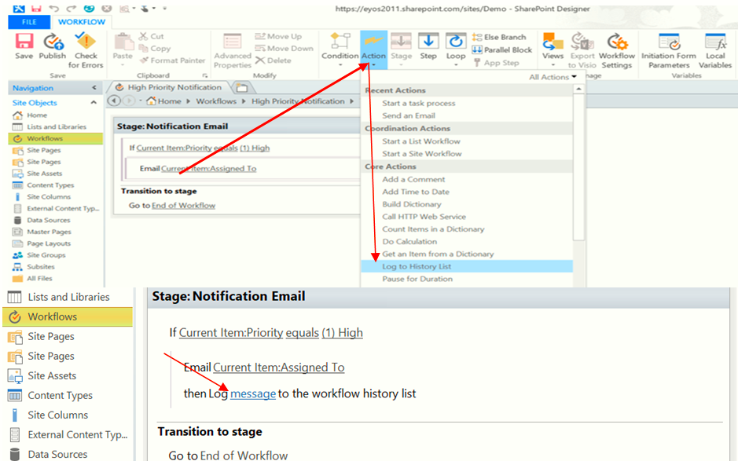

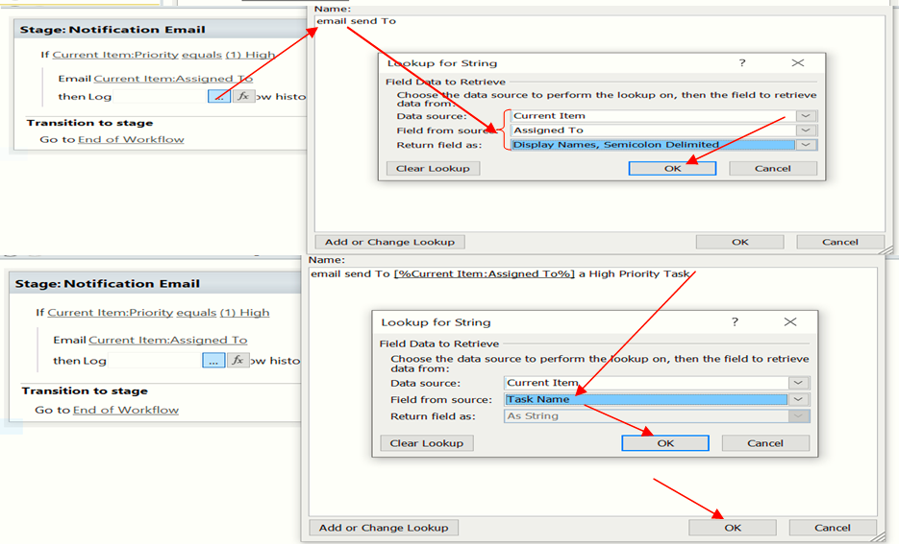

## Else Condition:

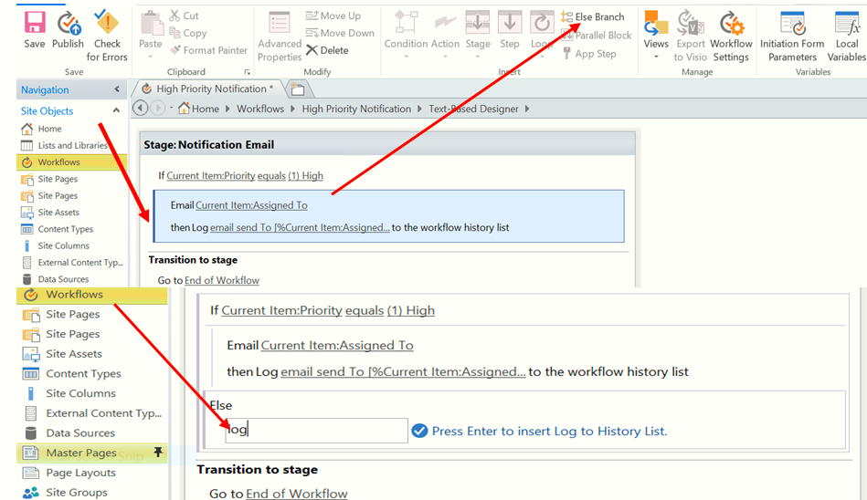

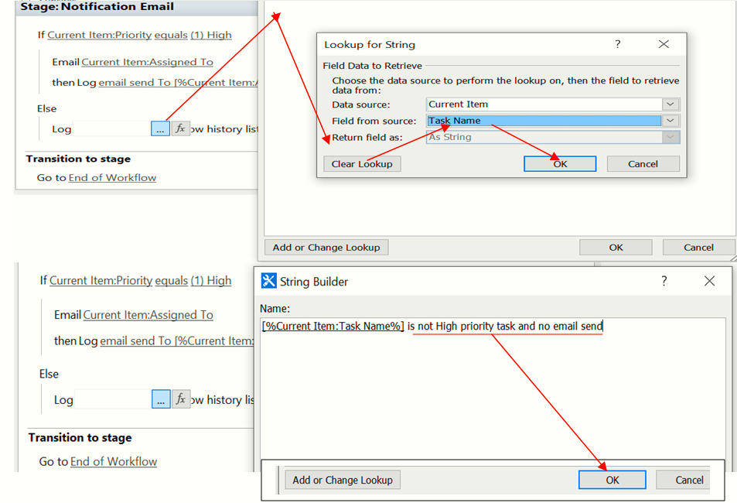

## Set workflow status

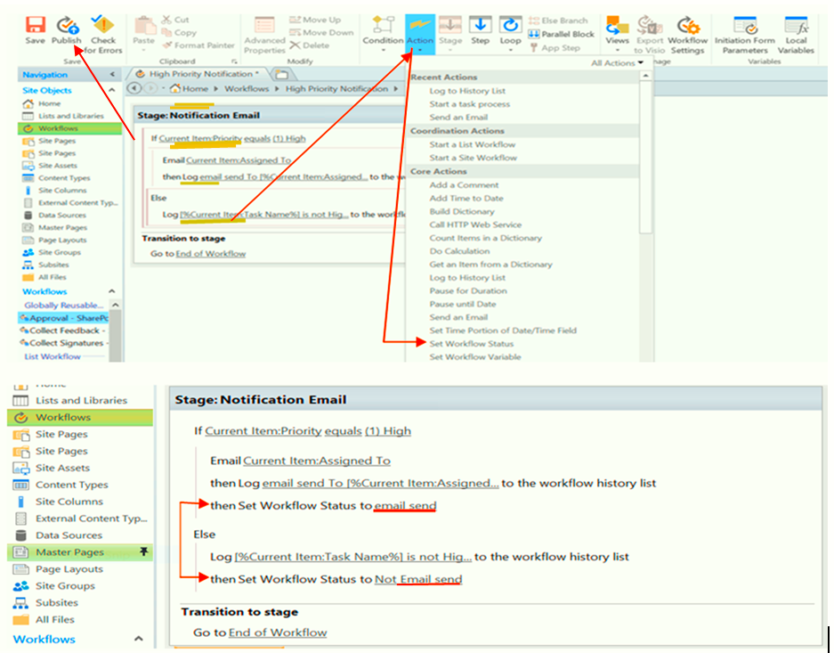

## Editing to send Notification email

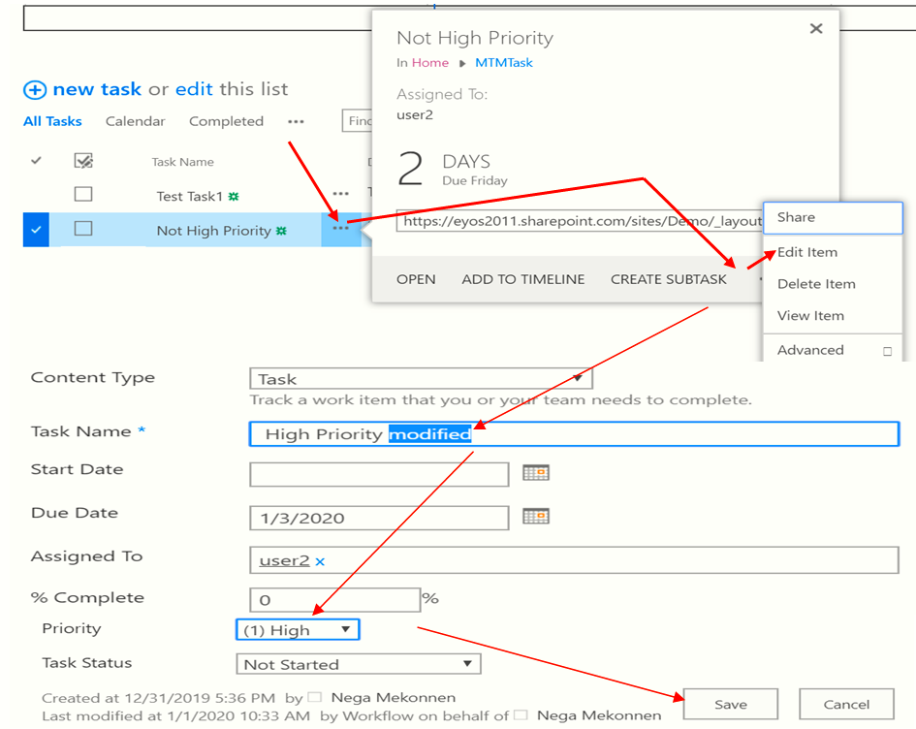

**Then we get The following Notification email**

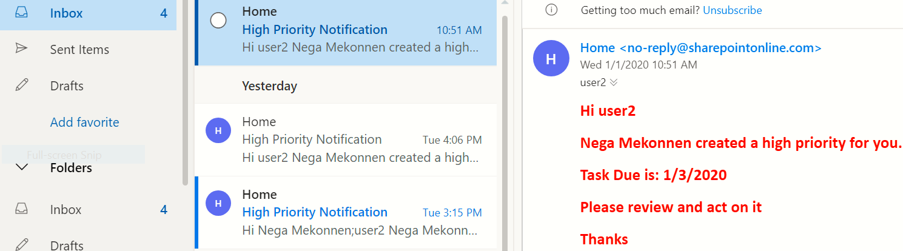

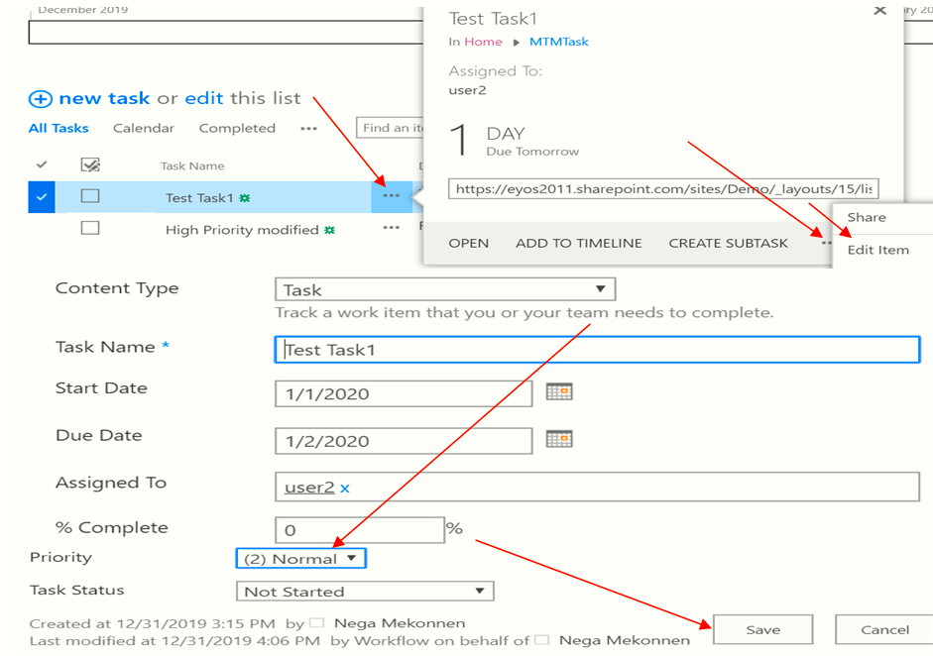

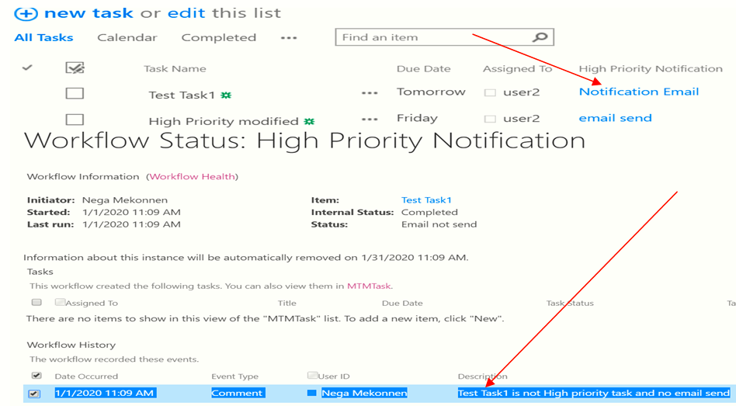

## SharePoint 2010 Workflow

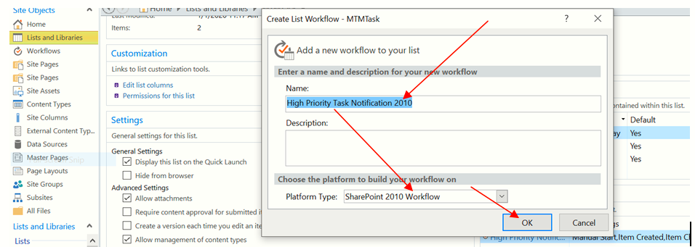

Compare 2013 and 2010 SharePoint Designer 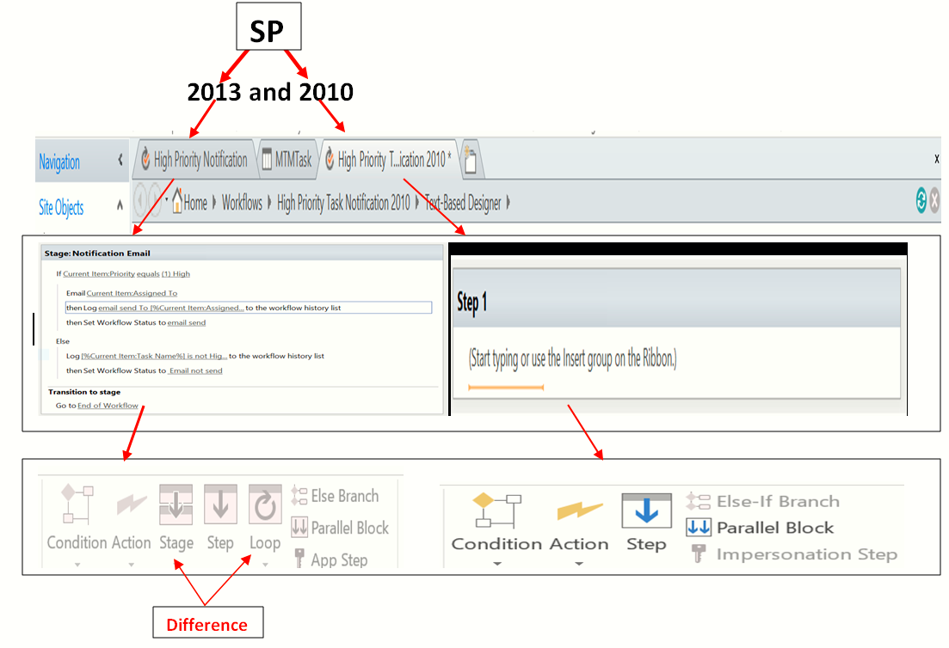

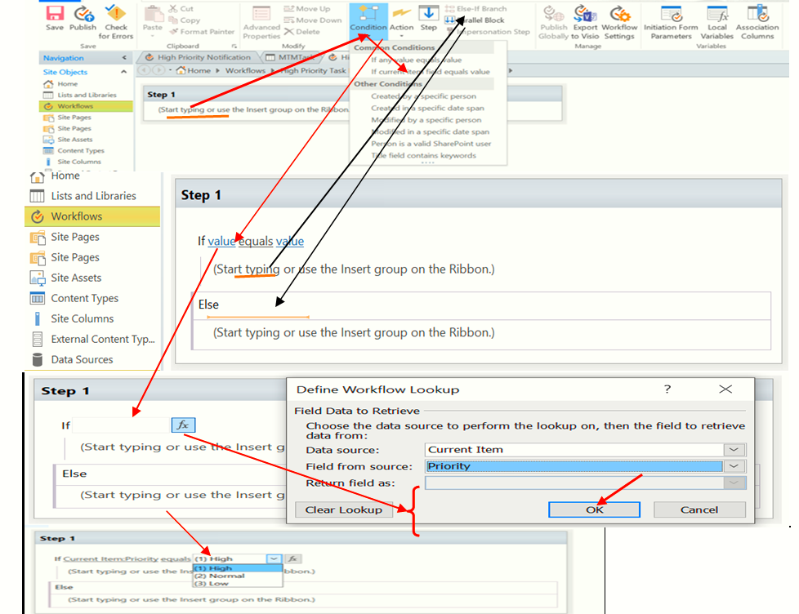

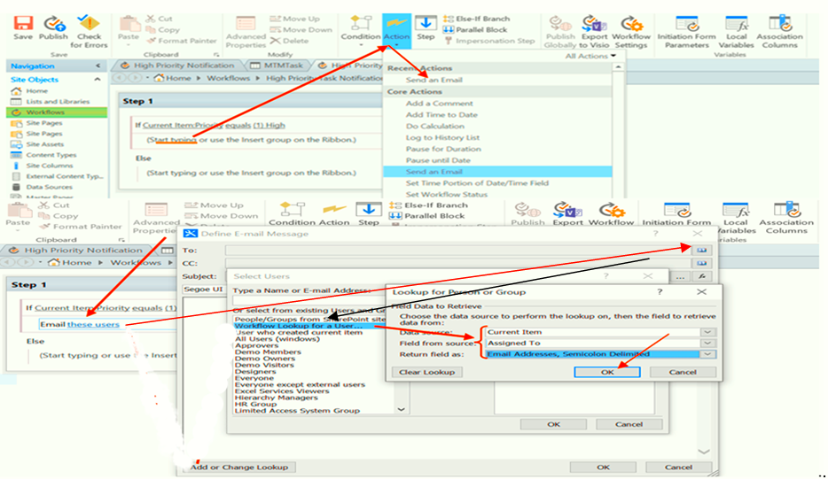

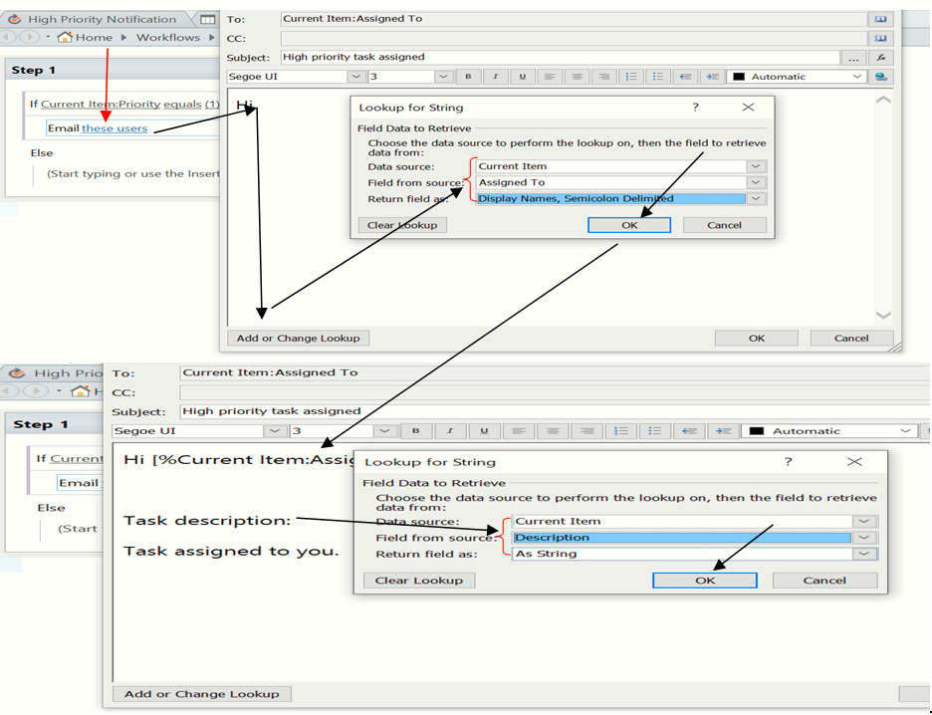

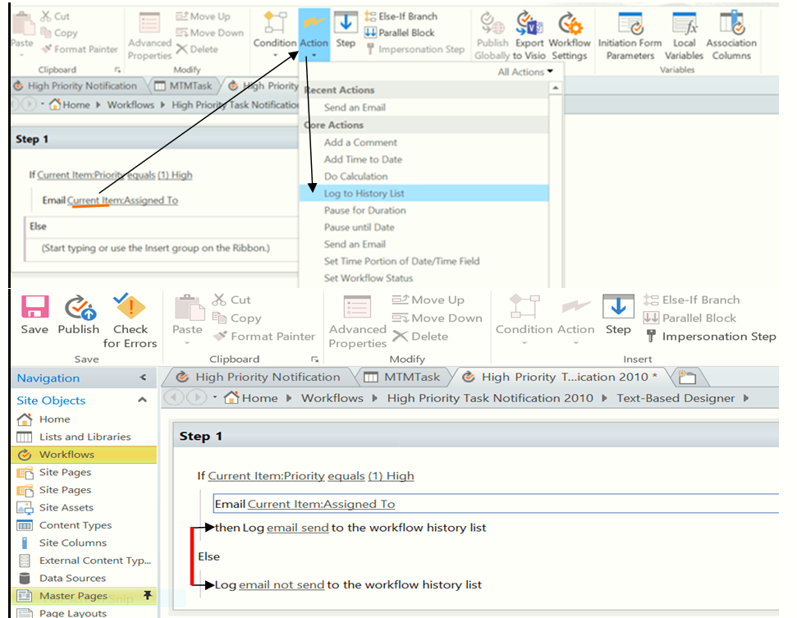

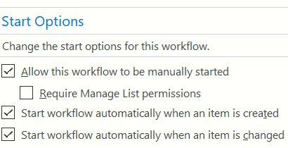

**Then publish it**

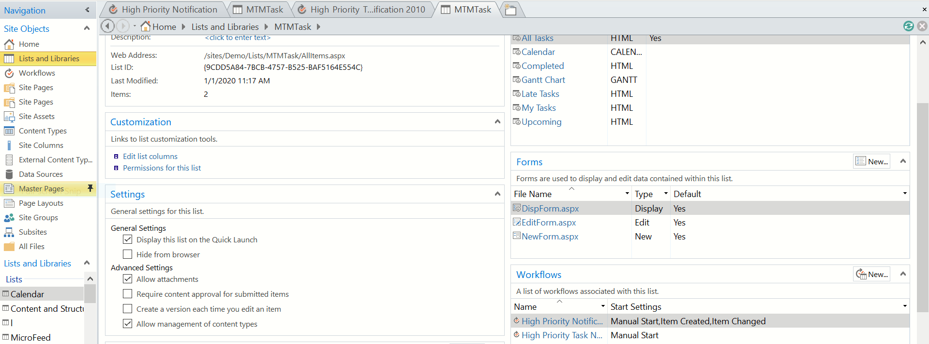

**Go to SP Browser and create item**

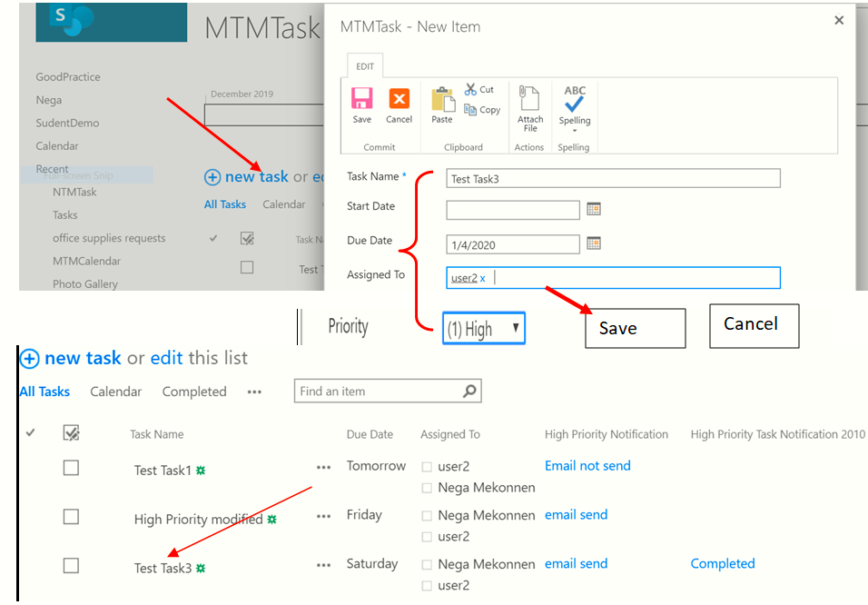

## How to Add custom Task

**List and Library =>MTMTask =>Under Workflow(High priority task notification) =>Edit workflow**

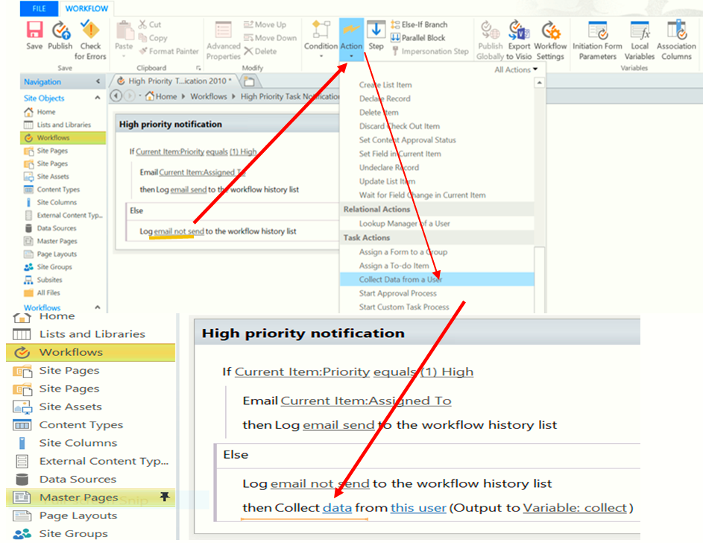

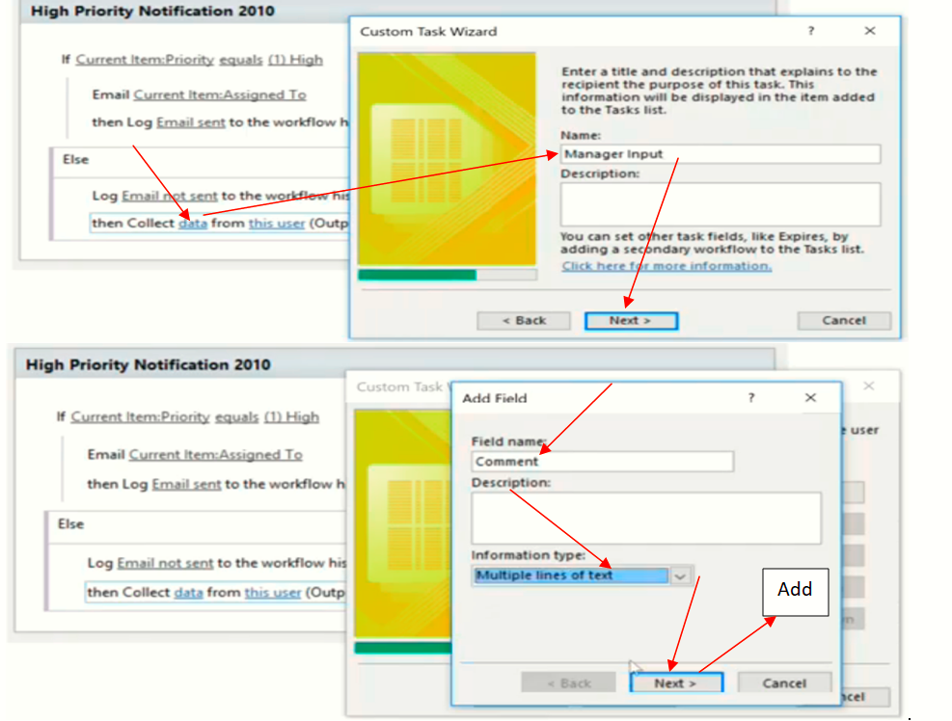

Add

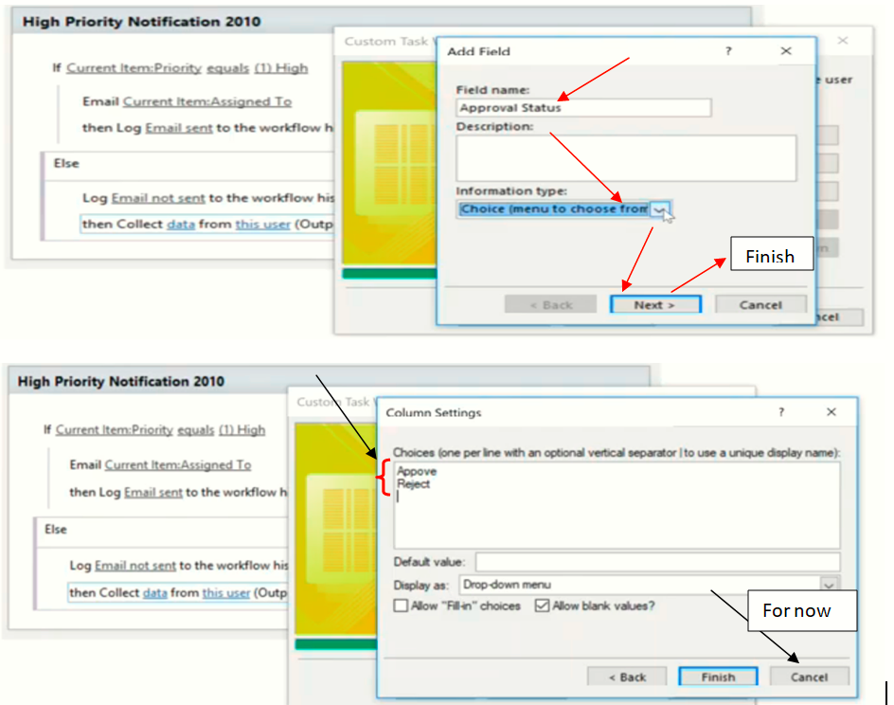

**End of Class 13**